Coverage Report

Using *Eclmma* coverage plugin I got following reports, Main class can’t be 100% of coverage due main method is only called by console, *Enum* can’t be instantiated. *FizzBuzzCalculator* only has a static method don’t need create an instance of it.

The generic catch inside StepMain for unexpected errors only can be thrown on unrepeatable scenarios and couldn’t be covered by JUnit.

## Step one

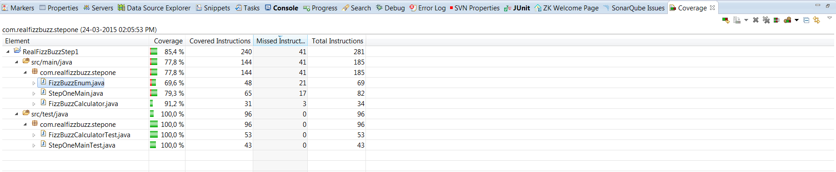

## Step two

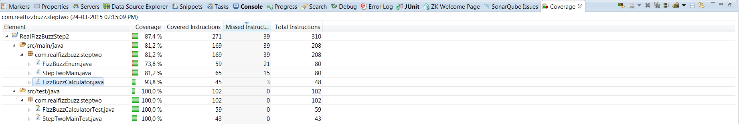

## Step Three

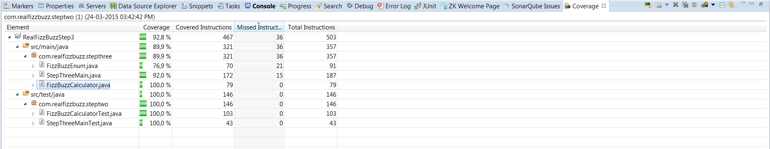

### Curiosity About Step three

In step three alternatively we should print the map using iteration, but the arrangement required (starting from fizz and ending with integer) wouldn’t be achieved by this loop:

// iterate over map and print values.

**for** (final Entry<String, Integer> entry : countMap.entrySet()) {

**final** String wordOrNumber = entry.getKey();

**final** Integer count = entry.getValue();

System.*out*.print(wordOrNumber);

System.*out*.print(*COLON*);

System.*out*.print(*SPACE*);

System.*out*.println(count);

}

Due arrangement requirement I had to use this literal reference for the keys.